Trouble Detail

Project | PIS-FRAME | Customer | IMCT
By | Chirayuth S. | Date | 04/04/2011
Problem | Cannot Start Frame-Server Program  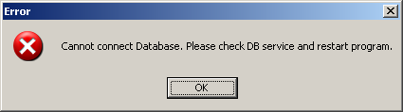
Cause | Host name and IP mapping in hosts file was changed.  From  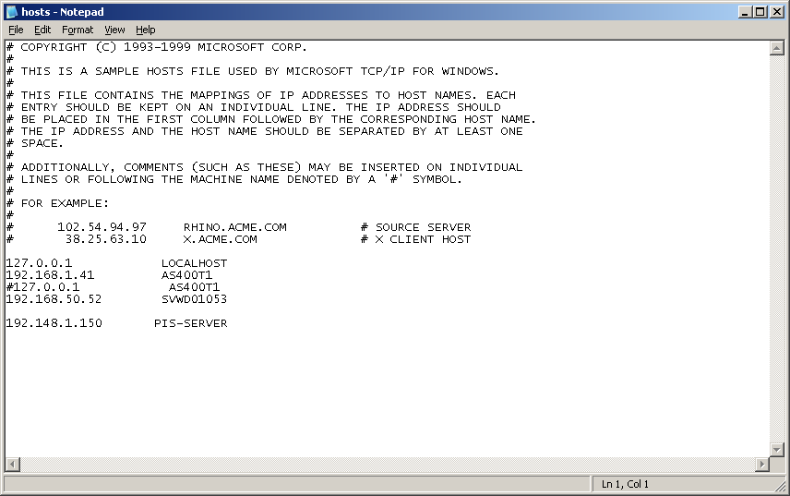  To  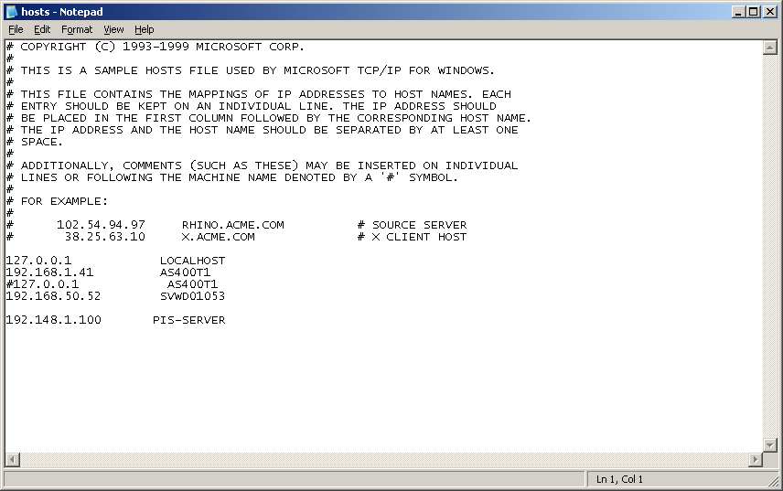
Relation | There is some file used when developing PIS-BODY remain in the server.  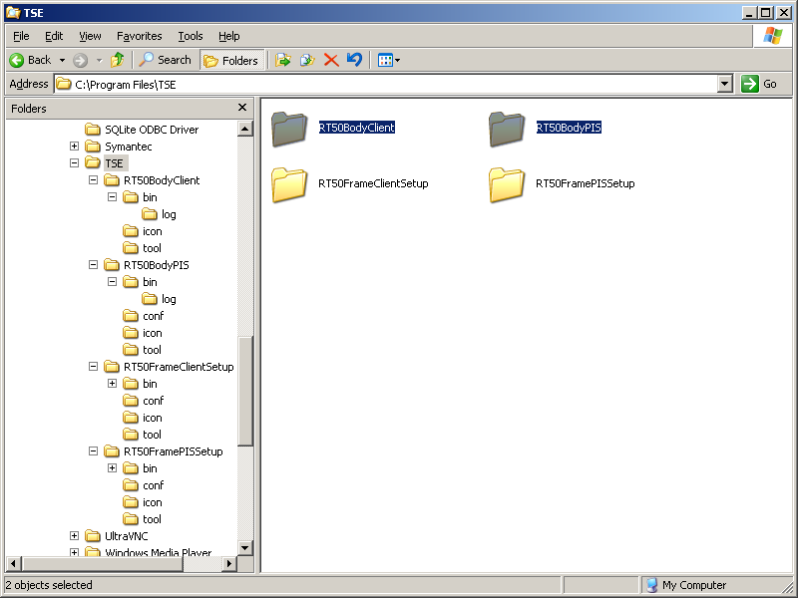  And in these folders, there is “addhost.exe” which is used to edit host file setting, if anybody run this program it will change the host file based on default IP of the PIS-BODY system.  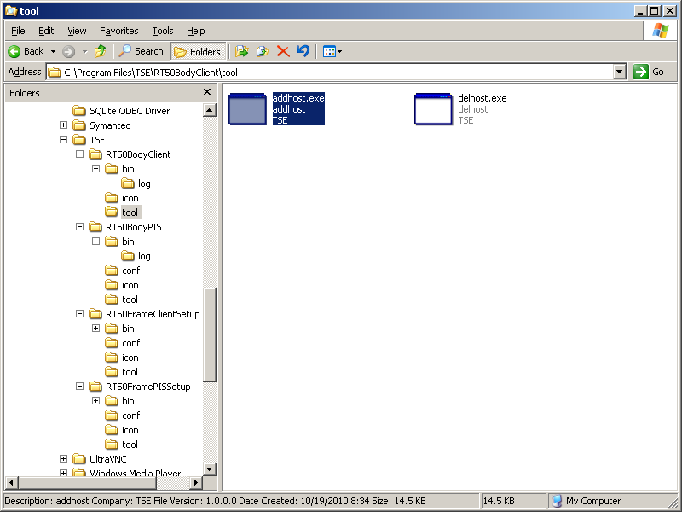
Solution | Delete all PIS-BODY related files to prevent this case to happen again.
Document
Remarks

